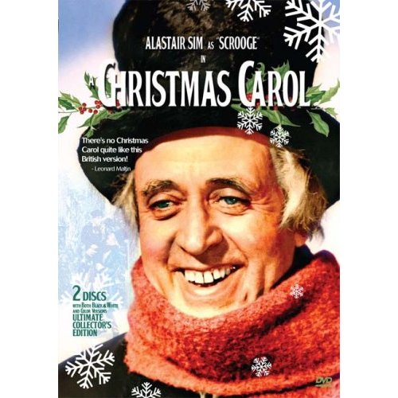
“He became as good a friend, as good a master, and as good a man, as the good old city knew, or any other good old city, town, or borough, in the good old world.”
Guidelines
The work you complete for this unit is to prepare you for the Unit Test which all of you will take. It will consist primarily of MCQ’s in order to prepare you properly for the Virginia state SOL Test.
For assignment due dates be sure to check our class webpage, calendar and Grade Record Sheet regularly.
Guidelines & Directions for each assignment will be distributed and explained at the appropriate time.
If you wish to look ahead, major project guidelines and some smaller assignments are already available on the webpage: http://rhondarobb.weebly.com/
Name____________________________
Period/Date_______________________
Ms. Robb: English 12
Unit: A Christmas Carol

A Christmas Carol
A Christmas Carol by Charles Dickens is one of the most beloved Christmas stories of all time. It has been translated in several languages and countless movie adaptations have been created. However, it is much more than a Christmas story. It is a story of greed, insight, kindness, love, hope, regret, and finally redemption. It is a story that transcends both religion and time; for it is a tale from which people of all ages and faiths can learn.
Charles Dickens (1812-1870) was the most popular British writer in the Victorian era and one of the most beloved writers of all time. He wrote countless novels bringing attention to London’s poor with the hope of social reform. He introduced us to some of literatures most memorable characters such as The Artful Dodger, Oliver Twist, Ebenezer Scrooge, David Copperfield, and Pip to name just a few.

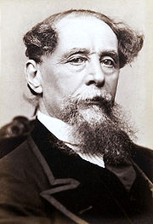
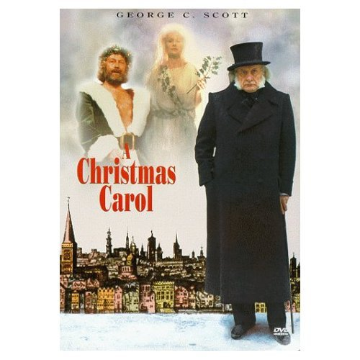

"I wear the chain I forged in life . . . I made it link by link and yard by yard; I girded it on of my own free will, and of my own free will I wore it." –The Ghost of Marley, Stave 1
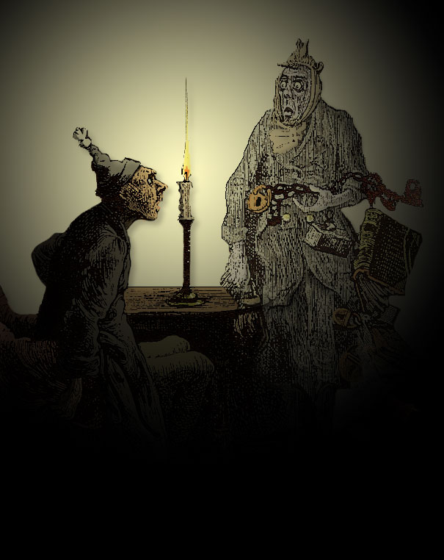
Ms. Robb-English 12
Literary Analysis Unit
A Christmas Carol
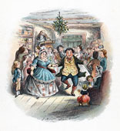
A Christmas Carol
Dinner Menu
Appetizer
INDIVIDUAL (Choose 1 of 2)
1. Obituary: What should Dickens be known for? OR
2. Create a fine art piece representative of Victorian culture.

COLLABORATIVE (Choose 1 of 2)
1. Group performance piece demonstrating significant aspects of Victorian culture. OR
2. Group develops Parliamentary proposal to address social problems of Victorian period.

Soup & Salad
1. Unit Map AND
2. Word Play (Vocabulary)

Main Course
INDIVIDUAL (Choose 1 of these options if you plan to complete the unit project on your own.)
1. Interactive technological presentation related to a theme or characterizations in the text . OR
2. Rewrite a scene from the text with a character from a contemporary TV show as the main character. OR
3. 3-D Artifact with presentation.

COLLABORATIVE TEAMS (Choose 1 of the options if you plan to complete the unit project as part of a group.)
1. Create a PhotoVoice project focusing on themes or characterizations in the text. OR
2. Produce and present a video of one scene from the book to our class. OR
3. Produce and perform a theatrical or musical sketch of one scene from the book.
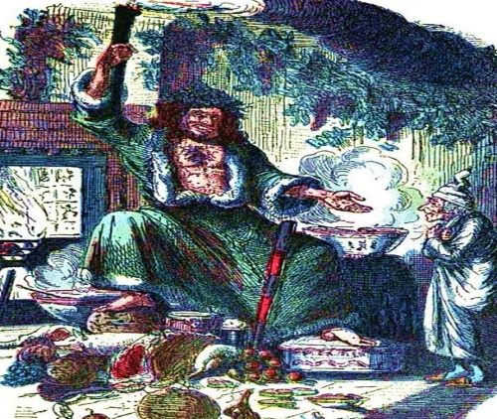

Specials: Choose a Quiz Option
QUIZ 1: 4 Essay Questions. OR
QUIZ 2: 40 Multiple Choice Questions.

Side Orders
Choose one from among the individual and paired options.
INDIVIDUAL
1. Illustrated timeline of novel and literary significance of these events.
2. Primary source documents: read 2 related to Victorian era themes addressed in Dickens' book and answer corresponding questions.
PAIRED
1. Interview character and present to class.
2. Create a poster or Power Point presentation which illustrates 4 figurative devices used in ACC.

Dessert (optional extra credit)
1. Journal Check--If you keep a reading journal, I will read and evaluate it for extra points if you offer insight and engage critically, intellectually, and reflectively with the text.
2. Socratic Seminar--Earn extra points if you participate by adding thoughtfully, reflectively, and intellectually to the process.
Bon Appétit!

