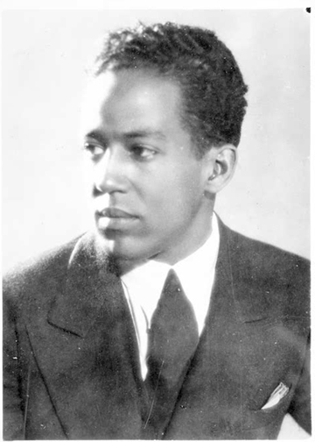
A Dream Deferred- Langston Hughes
What happens to a dream deferred?
Does it dry up
like a raisin in the sun?
Or fester like a sore--
And then run?
Does it stink like rotten meat?
Or crust and sugar over--
like a syrupy sweet?
Maybe it just sags
like a heavy load.
Or does it explode?
__________________________
A Raisin In the Sun
By Lorraine Hansberry

